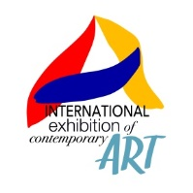

*created and organized by*



*under the patronage of*

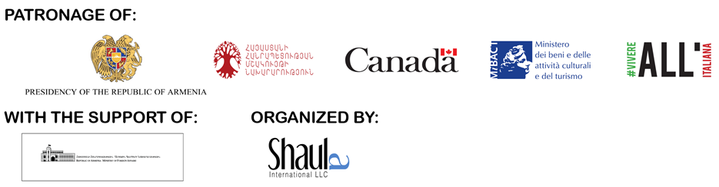   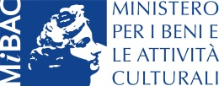  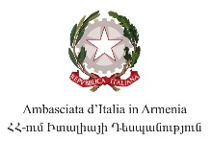

*with the support of*

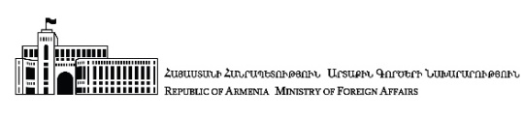 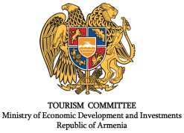   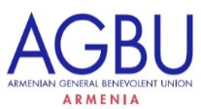

EUROPEAN UNION #EuropeforCulture

**INTERNATIONAL CONTEMPORARY ART EXHIBITION:**

**ARMENIA 2018 (ICAE2018)**

**SOUNDLINES OF CONTEMPORARY ART**

*curated by Mazdak Faiznia and Marina Hakobyan*

**28 September – 25 October 2018**

opening ceremony Friday 28th September, 7 pm - National Gallery of Armenia

**Armenia, Yerevan**

Armenian Center for Contemporary Experimental Art

Aram Khachaturian Museum

Cafesjian Center for the Arts

HayArt Cultural Center

A. Spendiaryan Opera and Ballet National Academic Theatre

Armenian General Benevolent Union

Artists’ Union of Armenia

*press release, 25.09.2018*

On the occasion of the hundredth anniversary of the birth of the Republic of Armenia, **Yerevan** opens its doors to contemporary art with the grand exhibition "International Contemporary Art Exhibition: Armenia 2018 (ICAE2018). Soundlines of Contemporary Art". From the **28th of September to the 25th of October,** artworks by **more than seventy international artists** will be exhibited in seven important locations throughout Armenia’s capital. The event also includes an extensive program of workshops and talks with international experts from the art world.

The exhibition combines contemporary **painting, sculpture, photography, video, and installation of iconic works on loan from the world’s top galleries and collections, as well as commissioned works realized by the artists *in situ***. A number of the invited artists will be holding presentations and workshops with the students of the Fine Arts Academy of Armenia, Terlemezyan State College of Fine Arts, and at the Tumo Center for Creative Technologies. Through exhibition, workshops, and presentations, the event aims to engage the territory in international artistic debate and cultural exchange. The exhibition and program extend across seven locations that include the following cultural venues: Armenian Center for Contemporary Experimental Art, Aram Khachaturian Museum, Cafesjian Center for the Arts, HayArt Cultural Center, Artists' Union of Armenia, A. Spendiaryan Opera and Ballet National Academic Theatre, Armenian General Benevolent Union (AGBU).

**"Soundlines of Contemporary Art"** is curated by Mazdak Faiznia and Marina Hakobyan, is conceived by Fabio Lenzi and Alberto Cagliostro and is organized by “Shaula International” LLC. The event has the patronage of the Canadian Government, the Government of Québec, the Ministry of Culture of the Republic of Armenia, the Ministry of Cultural Heritage and Activities in Italy (MiBAC), the cultural promotion project of the Italian Foreign Ministry “Vivere all’Italiana”, the Embassy of Italy in Armenia and it is supported by the Ministry of Foreign Affairs of the Republic of Armenia, the Armenian Tourism Agency, the EU Delegation in Armenia and by the Armenian General Benevolent Union (AGBU).

The title, "Soundlines of Contemporary Art", evokes *The Songlines (1987*), the well-known book by Bruce Chatwin on the oral traditions of the Australian aborigines, and in particular, how a mapping of the territory is derived from the incorporation of "Dreamtime” (a mythological time sense), song, and nomadic travel. The exhibition reveals how Armenian art is harmoniously in tune with international contemporary art, similarly to what happens in an orchestra in which the sound of the Armenian duduk integrates perfectly with other instruments.

"Soundlines" highlights important concepts such as those of **cultural interaction, identity, mobility, presence / absence, circulation of thought, territory, and borders** as physical and mental thresholds that both divide and permit exchange and cultural dialogue. The exhibition proposes **idealized maps** of the territory and its problematic horizons, where **memory and sound** are understood as voices that are not lost within globalization, and which are made distinct by silence whose necessary pause allows for reflection and interaction.

Bringing "Soundlines" to Yerevan within the context of the Hundred Years of the Republic of Armenia reveals the full participation of the country in the broader artistic debate and highlights its potential as a place for cultural exchange; at the same time it invites international artists to join the voice of Armenia and better understand its silence, which is full of unperceived sounds and still unexpressed thoughts.

Through visual metaphors in contemporary art, representing Italy are artists: **Rossella Biscotti**, **Alighiero Boetti**, **Loris Cecchini**, **Chiara Dynys** and **Roberto Pugliese**, in a varied international context including artists: **Lida Abdul** (Afghanistan), **Adel Abidin** (Iraq), **Aboudia** (**Abdoulaye Diarrassouba**, Ivory Coast), **Etel Adnan** (Lebanon), **AES+F** (Russia), **Shahriar Ahmadi** (Kurdistan/Iran), **Francis Alÿs** (Belgium), **El Anatsui** (Ghana), **Arevik Arevshatyan** (Armenia), **Chant Avedissian** (Egypt/Armenia), **Sonia Balassanian** (Iran/Armenia), **BGL** (Canada), **Sanford Biggers** (USA), **Christian Boltanski** (France), **Herman De Vries** (The Netherlands), **Latifa Echakhch** (Morocco), **Victor Ehikhamenor** (Nigeria), **Arman Grigoryan** (Armenia), **Shilpa Gupta** (India), **Diana Hakobyan** (Armenia), **Sarkis Hamalbashyan** (Armenia), **Mona Hatoum** (Lebanon), **Sahand Hesamiyan** (Iran), **Hiwa K.** (Kurdistan/Iraq), **Ilya & Emilia Kabakov** (Russia), **Lee Kit** (China), **Julia Krahn** (Germany), **Roland Emile Kuit** (The Netherlands), **Hiroyuki Masuyama** (Japan), **Sirak Melkonian** (Iran/Armenia), **Karen Mirzoyan** (Armenia), **Kevork Mourad** (Syria/USA), **Moataz Nasr** (Egypt), **NeSpoon** (Poland), **Nicky Nodjoumi** (Iran), **Melik Ohanian** (France/Armenia), **Adrian Paci** (Albania), **Imran Qureshi** (Pakistan), **Jon Rafman** (Canada), **Tomas Rajlich** (Czech Republic), **Anri Sala** (Albania), **Ararat Sarkissian** (Armenia), **Walid Siti** (Kurdistan/Iraq), **Léon Tutundjian** (Turkey/Armenia), **Piotr Uklański** (Poland), **Mohsen Vaziri-Moghaddam** (Iran), **Lawrence Weiner** (USA), **Sislej Xhafa** (Kosovo), **Chen Zhen** (China).

The extraordinary exhibition, **the first of its kind in the Caucasian region**, tells the world of art what it means to draw a **network of new myths** that derive from the imaginary world of artists; a world seen through the lens of their respective identities and *social backgrounds*, that synergize in resonance or dissonance with one another among the works of over seventy artists from all over the world. The presence of artists of the most diverse origins and cultural roots is the occasion for a fertile, unprecedented exchange of ideas and *know-how.*

**The event includes the exhibition "Open Sounds of Contemporary Art"** realized through an open call via an online application, and carefully selected by the curators in view of the exhibition at the important site of the Artists’ Union of Armenia, where you can visit the works of the following artists: Aram Danielyan (Armenia), Zack Demirtshyan (Armenia), Anush Ghukasyan (Armenia), Anna Grigoryan (Armenia), Anna Harutyunyan (Armenia), Ashot Harutyunyan (Armenia), Tehmine Harutyunyan (Armenia), Arthur Hovhannisyan (Armenia), Aram Isabekyan (Armenia), Arvin Kocharian (Armenia), Zara Manucharyan (Armenia), Lilit Meliqyan (Armenia), Paravon Mirzoyan (Armenia), Mary Moon (Armenia), Logo Oluwamuyiwa Adeyemi (Nigeria), Alessandro Pizzo (Italy), Maria Salmassian (Armenia) and Josette Taramarcaz (Switzerland).

**Two conference series** are organized within the framework of ICAE2018. The first, entitled **Educational**, which offers several workshops in the main Armenian institutes - including the Tumo Center for Creative Technologies, the Panos Terlemezian State College of Fine Arts, the State Academy of Fine Arts of Armenia - held by the artists Roberto Pugliese, Roland Emile Kuit, Logo Oluwamuyiwa Adeyemi, Victor Ehikhamenor and Milano Printmakers. The second, entitled **Business in Art**, offers in collaboration with the European Union a conference on "Safeguarding, protection and valuation of cultural heritage" in order to introduce international standards within the cultural sector, and in partnership with AGBU a conference entitled "The Art & Business Symposium" to share international expertise on various facets of the art market.

In the context of the show there are numerous side events and discussions with reputed experts of the sector, such as critics, artists, gallery owners and collectors, in addition to logistics and insurance professionals, giving life to a **rich cultural program**.

The "ICAE2018", its multi-location exhibit and extensive educational programming, is included as a side event in the annual summit of the International Organization of Francophonie in Yerevan and coincides with the celebration of the 2800th anniversary of the birth of the city of Yerevan. Both appointments will converge a large audience formed by official delegations, institutional and other important participants coming from different nations.

The exhibition will be accompanied by a comprehensive two-volume **catalogue**, published by Manfredi Edizioni, with texts in English by curators Mazdak Faiznia and Marina Hakobyan and Shaula International LLC. The first volume is dedicated to "Soundlines of Contemporary Art", the second to the project "Open Sounds of Contemporary Art".

We would like to thank for their support: *Armenian General Benevolent Union (AGBU), the Faiznia Family Foundation (FFF), Hovnanian International LLC, JHM Foundation, Suardi Armenian Branch, the Foundation of Regional Development and Competitiveness, the Jurisdiction Armenia Foundation, Keush LLC, Zulal LLC, Best Western Congress Hotel, iSolutions LLC, Lori Ardaz, Tufenkian Hospitality LLC, Fondation Armenia, Arternativa s.r.l., the Non-Governmental Organization of Armenian Erudite Youth.*

*Special thanks to Mr. Vahé Gabrache.*

**COORDINATES OF THE EXHIBITION**

**Title:** International Contemporary Art Exhibition: Armenia 2018 (ICAE2018). Soundlines of Contemporary Art

**Curated by:** Mazdak Faiznia and Marina Hakobyan

**Dates:** 28th September - 25th October 2018

**Opening:** Friday 28th September, 7 pm - National Gallery of Armenia, 1 Aram Street, Yerevan, Armenia

**LOCATIONS**

**Armenian Center for Contemporary Experimental Art**, 1/3 Buzand Street, Yerevan, Armenia

Opening hours: Tuesday - Saturday, from 11-17

**Aram Khachaturian Museum**, 3 Zarobyan Street, Yerevan, Armenia

Opening hours: Monday – Friday, from 11-17; Saturday, from 11-16:30

**Cafesjian Center for the Arts**,10 Tamanyan Street, Yerevan, Armenia

Opening hours: Tuesday - Thursday, from 11-17; Friday - Sunday, from 10-20

**HayArt Cultural Center,** 7a Mashtots Street, Yerevan, Armenia

Opening hours: Monday - Saturday, from 11-17

**Artists’ Union of Armenia**, 16 Abovyan Street, Yerevan, Armenia

Opening hours: Tuesday - Sunday, from 11-17

**A. Spendiaryan Opera and Ballet National Academic Theatre**, 54 Tumanyan Street, Yerevan, Armenia

Opening hours: Monday - Saturday, from 10-18

**Armenian General Benevolent Union**, 2/2 Melik Adamyan Street, Yerevan, Armenia

Opening hours: Monday- Friday, from 9-18

**Catalogue:** Manfredi Edizioni, in English, with opening sections by Shaula International LLC and the curators Mazdak Faiznia and Marina Hakobyan.

**Entrance:** free

**Info for the public:** [info@icaearmenia.org](mailto:info@icaearmenia.org) - mob. +374 77 25 09 18

**ICAE2018 Official Website:** [www.icaearmenia.org](http://www.icaearmenia.org)

Facebook: ICAE2018

Instagram: icae2018

Official Hashtag: #ICAE2018

**Press Office for Italy:**

**IBC Irma Bianchi Communication**

Ph. +39 02 8940 4694 - mob. + 39 328 5910857 - [info@irmabianchi.it](mailto:info@irmabianchi.it)

texts and images from [www.irmabianchi.it](http://www.irmabianchi.it/en/mostra/international-contemporary-art-exhibition-armenia-2018-icae2018-soundlines-contemporary-art)

**Press Office for Armenia:**

**AGBU Armenia**

Communication Manager: Narine Hayrapetyan

mob. +374 77 59 99 61 – [narineh@agbu.am](mailto:narineh@agbu.am)